**Meeting Minutes**

**Date:** March 13, 2014

**Start Time:** 3:30pm

**End Time:** 6:00pm

**Members Present:** Drew Aaron, Michael Beaver, Clay Boren,

Chad Farley, Andrew Hamilton, and Travis Hunt

**Members Absent:** N/A

**Topics** **Discussed**

* Coding Standards
* Backend Design and Dataflow
* Frontend Development

**Decisions and Actions Taken**

Andrew updated the coding standards to include details on the function prologues. The coding standards have been submitted for approval.

Chad and Michael worked on the Backend Design and Dataflow. They outlined the Backend organization in terms of instantiated objects used by a centralized Processor class that will interface with the Frontend. They also outlined the dataflow for the two passes of the Assembler. Parts of these dataflow diagrams, such as “Process Input” in Pass 1, need further defining and refinement. See the attached design and dataflow diagrams.

Andrew, Clay, and Travis worked on developing the Frontend. They mainly focused on developing the custom Source Code Editor. They experimented with different methods for displaying line numbers and column numbers. An attempt was made to use dynamically instantiated label objects for each line within the Source Code Editor, but this was deemed unwieldy and inefficient. Instead, a proposal was made to use a separate (read-only) textbox to the left of the Source Code Editor to mark the line numbers. If this approach works, then a similar approach will be used for the column numbers.

The next team meeting will be Friday, March 14, 2014 at 6:00pm in the Christian Student Center. A team meeting has been scheduled for Saturday, March 15, 2014 at 2:00pm in the Christian Student Center.

**Supplementary Information**

**Backend Processor**

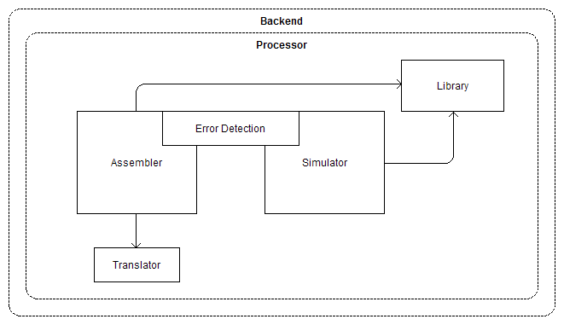

**Assembler Pass 1 Dataflow Diagram**

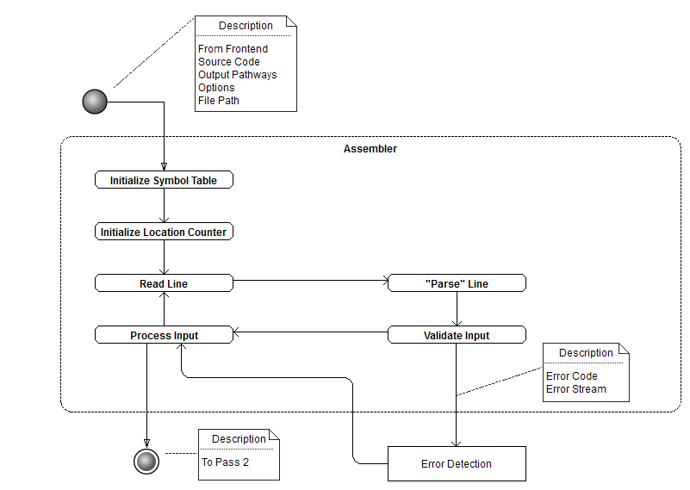

**Assembler Pass 2 Dataflow Diagram**

